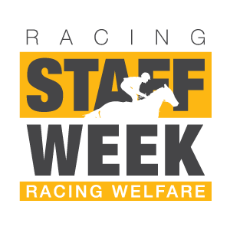
YOUR RACING COLOURS CAN FUNDRAISE FOR RACING WELFARE

Racing Staff Week runs from 27th June to 1st July and seeks to shine a light on the people who make racing happen in the UK. Every year our sport comes together to celebrate the skill, passion and dedication of racing’s workforce.

By placing your colours in the Doncaster Charity Raceday racecard on Friday 1 July, you will be making an important contribution to our fundraising target for the year, the cost is £100 per entry.
Body Colours and Pattern:

Sleeve Colours and Pattern:

Cap Colours and Pattern:

Name (as it should appear in the racecard):

Please return this form by Monday 10 June to:
Clare Kingston either by email to ckingston@racingwelfare.co.uk or by post to Racing Welfare, 20b Park Lane, Newmarket, Suffolk, CB8 8QD
Please make cheques payable to Racing Welfare and post to the above address.

If you would prefer pay by BACS our account details are:
Sort Code: 20-60-38 Account No: 70624837 Please use ref (your name) DONC19
Name
_______________________________________________________________________________________________
Address _______________________________________________________________________________________________
_______________________________________________________________________________________________
Telephone _____________________________________________________________________________________
Email _________________________________________________________________________________________

