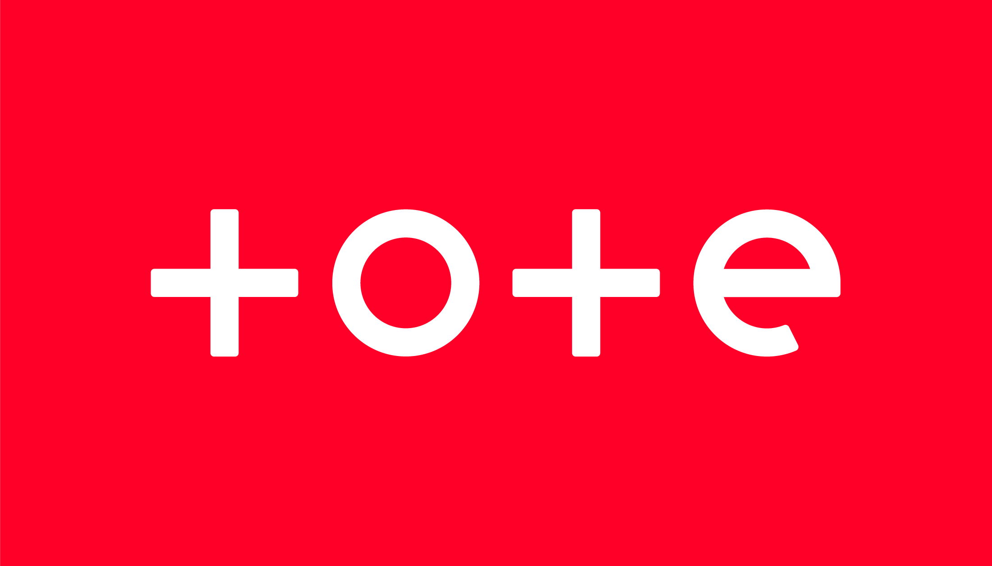 | TOTE / ROA  OWNER-SPONSORSHIP SCHEME  July 2025 | 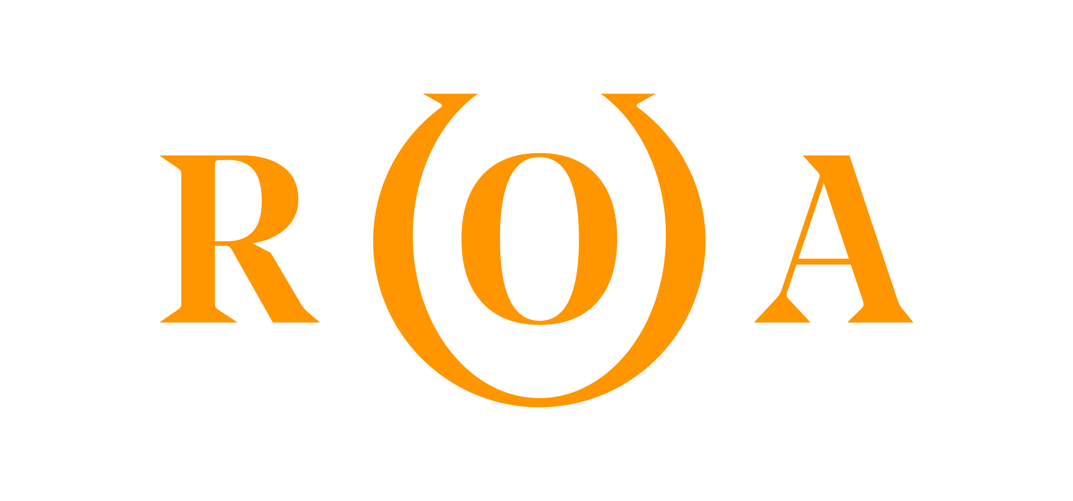
- This Agreement will run from 1st July 2025 – 30th June 2026 (the ‘Sponsorship Period’).
- Horses must be registered in the owners’ name (‘Owner’) and listed as in full training with Weatherbys to qualify.
- Qualifying horses must carry the Tote logo (Tote, Tote Placepot & Tote.co.uk) as provided on patches fixed to the chest and collar of the Owners’ silks each time they run in Britain during the Sponsorship period with the exception of any named races excluded as detailed in the Racing Calendar.
- Upon being accepted onto the scheme for the Sponsorship period, the Owner will receive a payment of £100 per horse (plus VAT if applicable) as the Sponsorship Fee payment once this scheme has closed (1st July 2025). No refunds shall be payable to an Owner who elects to terminate the arrangement prior to the expiry of the Sponsorship Period.
- Should Tote logos be required the Owner agrees to contact John at Horse Requisites on 01638 664619 and pay the required handling and postage fee (£22+ VAT). The logos conform to the size as detailed in the British Horseracing Authority (BHA) Code of Conduct.
- A fee in accordance with Schedule (A)1 is due to the BHA at the time of registration.
- The sponsorship agreement must be signed by the Owner or one of their representatives and the Owner confirms that it has full title and authority to enter into this Agreement and is not bound by any previous agreement which adversely affects this Agreement.
- Sole Owners of participating horses must be members of the ROA. In the case of a Syndicate or Racing Club, all Syndicate or Club managers need to be ROA members in order for the horse to be eligible for this scheme. Where the horse is owned in a Joint Partnership, all Owners need to be ROA Members.
- For joint-owned horses, Sponsorship Fee payments are split among partners or be paid into the partnership account, according to how the ownership is set up. Any change of ownership during the Sponsorship Period must be notified immediately to the ROA.
- It is intended by the ROA and Tote that no jockey who is below the age of 18 years of age shall bear the Tote and World Pool logo’s in the manner set out in this Agreement. All terms of this Agreement remain unaffected should a jockey below the age of 18 be instructed to ride without the Tote logos being displayed.
- During UK World Pool race events any Tote logos will be automatically replaced with a specific World Pool logo for display and will be provided on each raceday within the Weighing Room, with no action needed by Owners or Trainers.
------------------------------------------------------------- Cut here and retain top portion -----------------------------------------------------
TOTE / ROA OWNER-SPONSORSHIP–AGREEMENT TO START ON JULY 1ST 2025
Please complete in BLOCK CAPITALS and return to: ROA Owner-Sponsorship Scheme, Racehorse Owners Association, 12 Forbury Road, Reading, Berkshire, RG1 1SB

Name of Owner(s) __________________________________ Membership number(s) ______________________

Address ________________________________________________________________________________________

Telephone number(s) ____________________________ E-mail address ____________________________________

Name of horse __________________________________ Trainer___________________________________________

Name of horse __________________________________ Trainer___________________________________________
(please use back of sheet if there are additional horses to be sponsored)
I/we confirm that I/we would like the horse(s) listed above to participate in the TOTE / ROA Owner-Sponsorship scheme starting on 1st July 2025. I/we agree to abide by the terms detailed above and I am/we are aware of the terms of the BHA Racehorse Owners’ Sponsorship Code of Conduct. (Please contact the BHA if you require a copy of this Code.)

Owner name __________________________________Signed ___________________________ Date _____________

